Rancocas Creek Farm

Farm Apprenticeship

Overview

Rancocas Creek Farm is a venture started by the Pinelands Preservation Alliance (PPA) in 2020. We are undertaking an effort to transform a 72 acre conventional soybean farm into a diverse, chemical-free, regenerative farm. Our goal is to grow high quality produce by growing healthy annual and perennial crops. Our focus is also on managing stormwater and rebuilding soil health by using plantings, mulches, composts, cover crops and crop rotations. In 2020 we grew produce on 3.5 acres and sold produce to restaurants, markets, wholesalers and made donations to food pantries and soup kitchens. In 2021 we grew on 9 acres and established a CSA for150 families. We also sold produce to restaurants, a caterer and off-farm clients. In addition we raised 7 pigs on pasture and grew rye for straw. And in 2024 we had over 360 families join our CSA, we raised 12 pigs on pasture and we harvested our 2nd crop of Asian Pears from the orchard we started in 2020. The work we do at the farm is designed to help promote the mission of the Pinelands Preservation Alliance, a non-profit protecting New Jersey’s Pinelands since 1989. Farm staff are also part of the PPA team and all of our work helps protect New Jersey’s wildlife, waterways and provide greater access to natural spaces.

Of course all of this is a lot of work and requires many hands! To address our needs and to help train the next generation of farmers and food growers, we are offering Farm Apprentice positions. This is an opportunity for interested candidates to get real hands-on experience on a working farm. The workload will be diverse and will include just about everything that needs doing on the farm.

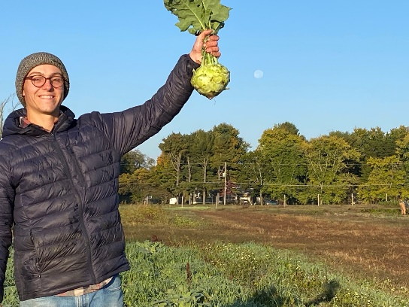

Apprenticeship

Our goal is to find qualified individuals, provide them with proper training and oversight, and give them tasks working with others or individually that require responsibility and quality work. The farm workload, especially in the summer months, is heavy, so we all try to approach jobs with the goal of getting them done in a manner that is *“Thorough and Quick*”. That is, we want to do all of our jobs well and also in a timely manner. Farm work can be tough and physically demanding; that is just the reality of the profession. Our goal is to help beginning farmers learn the ropes, get acclimated to the pace and have success helping to run a productive farm operation. Candidates don’t need to be physical superstars, but they should possess a certain level of fitness and ability to handle physical work, day-in and day-out in all kinds of weather. We aim to provide Apprentices with a very full, productive and rewarding farm season. At the end of the year, Apprentices will have developed a solid foundation for understanding the principles of sustainable, regenerative agriculture and how to manage the daily challenges and ins and outs of the farm season.

The Apprenticeship will run from ***Monday, March 16th to Tuesday, November 24th 2026.*** The schedule will vary somewhat with the growing season: for instance we generally start earlier when the weather gets hot and on distribution days. The general schedule will be 8am – 5pm Monday – Friday. Each Apprentice will generally work 2 half-day Saturdays a month and have chores one Sunday per month as well. Each Apprentice will have 1 week off during the growing season and 3 personal days; these off-days will be scheduled with the Farm Manager. There may be days where the Apprentices are asked to stay late to get a timely job completed (say a big harvest before a major rain event or help moving irrigation during a drought period). Farming generally is not a 9 to 5 job! But we do our best to respect everyone’s time and stick to as normal a schedule as we can.

Educational Opportunities

Apprentices will be given opportunities (generally 2 per month) to take advantage of educational opportunities to expand the breadth and depth of their agricultural experience. These may be in the form of farm tours, workshops, trainings, conferences etc. We are a part of NJCRAFT (Collaborative Regional Alliance for Farmer Training) and participate in the network’s farm tours and gatherings. Opportunities may also come from NOFANJ, Rutgers Cooperative Extension or PASA. Apprentices will also have opportunities to be a part of PPA meetings, discussions and campaigns as they arise. Our work at the farm is always supported by and supportive of the work and mission of PPA.

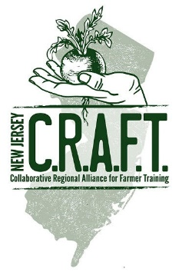

Apprentices will also be a part of a weekly farm meeting and crop walk. They will be given copies of the weekly plan and the field and crop records during the season. In the Fall, we will go over how to devise a crop plan and a seed order, and we’ll delve into farm budgeting and financial planning as well. At the conclusion of the Apprenticeship, the Farm Manager will be available as a resource to review farm plans, write references, and help with networking and farm opportunities.

Compensation

Apprentices will be paid $3,000 / month. Pay days are every other Friday via direct deposit. Apprentices also get whatever produce they need from the farm and pork from our pigs at the end of the season. Apprentices will also be reimbursed up to $150 for gear / farm clothes and a multi-tool. Apprentices will be eligible for workers compensation.

What The Apprentice Gives

Apprentices will be expected to be at the farm on-time, dressed appropriately and ready to work. The workload will be diverse and will include (but not be limited to): planting, hand weeding, hoeing, irrigating, mulching, feeding, watering and tending to livestock, harvesting, washing, packing, distributing and delivering produce, staffing the CSA distribution shop, making deliveries, and managing volunteers. Some days may involve many different tasks and others may be lots of one thing (i.e. big harvest days or planting days). Apprentices will be trained on tractor operation, safety and maintenance. Apprentices will have many opportunities to operate tractors and implements throughout the season. This may include seeding, transplanting, cultivating, mowing, discing, moving compost and so on. The Farm Manager will teach proper hook-up, use, and maintenance of all equipment.

Our farm team will include Apprentices, full-time farm staff, part-time staff, ‘workshare’ participants, volunteers, students and possibly summer interns. We work with all sorts of people and the expectation is that everyone on the farm is treated fairly, with respect and with acceptance.

Application

We are seeking candidates who are enthusiastic about growing food and working outside. The Apprenticeship at Rancocas Creek Farm ***is a commitment*** and will require participants to have a strong work ethic, positive attitude, can-do spirit and desire to work with all kinds of other people. This is an intensive, comprehensive and often ***fun*** opportunity for the right candidates! We are interviewing candidates on a rolling basis and will leave the job open until we find the right hires.

Candidates must be minimum 18 years old and have a valid drivers license. To apply, please send a letter of interest, resume, and references to:

Jeff Tober

Farm Manager

Rancocas Creek Farm

17 Pemberton Road

Southampton, NJ 08088

[jeff@pinelandsalliance.org](mailto:jeff@pinelandsalliance.org)

609 859 8860 x 130

*We are dedicated to furthering justice, equity, diversity and inclusion in our staff and work. We want everyone to know the Pinelands is theirs to enjoy through low-impact recreation, and to help people of all means and backgrounds to experience this natural treasure. All qualified applicants will receive consideration for employment without regard to age, race, creed, color, national origin, ancestry, marital status, affectional or sexual orientation, gender or disability.*